**Title of Project : Text-based RPG (role-playing game)**

**ID : 230240087**

1. **Programme:**

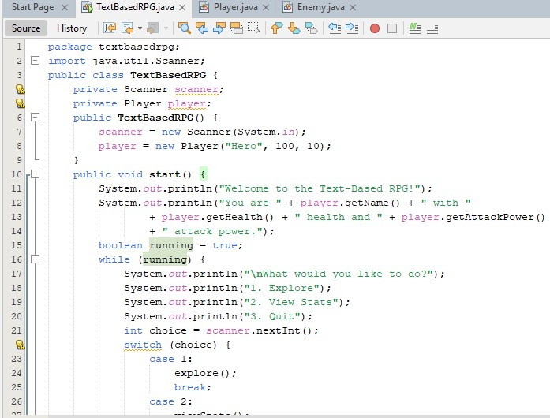

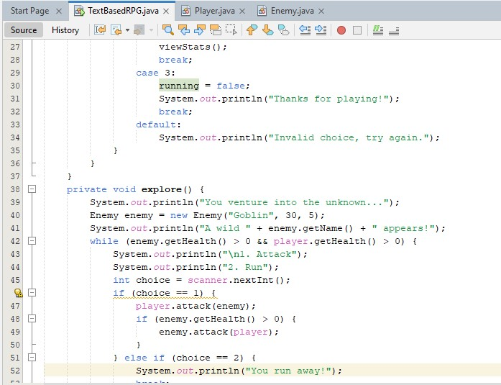

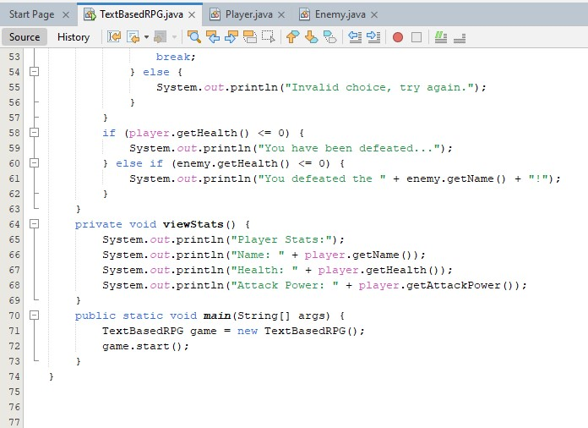

**Player Class:**

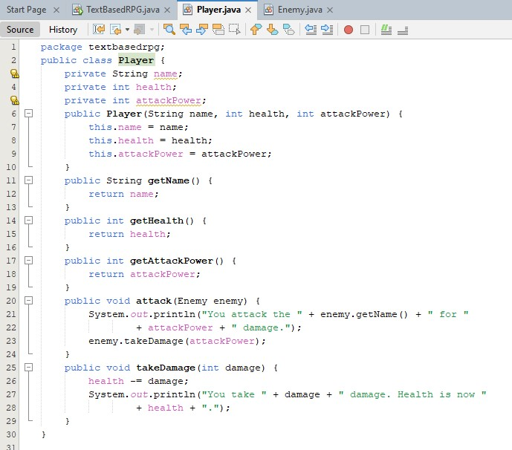

**Enemy Class:**

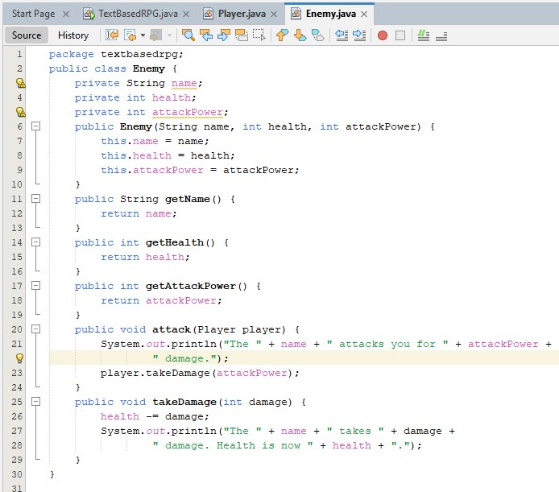

1. **Explanation:**
2. **TextBasedRPG Class**

* The TextBasedRPG class initializes the game with a Player and a Scanner for user input.
* The start method contains the main game loop, allowing the player to choose between exploring, viewing stats, or quitting the game.
* The explore method initiates an encounter with an enemy, and the player can choose to attack or run away.
* The viewStats method displays the player's current stats.
* The main method creates an instance of TextBasedRPG and starts the game.

1. **Player Class**

* The Player class defines the player's name, health, and attack power.
* The attack method allows the player to attack an enemy, dealing damage equal to the player's attack power.
* The takeDamage method reduces the player's health when they take damage.

1. **Enemy Class**

* The Enemy class defines the enemy's name, health, and attack power.
* The attack method allows the enemy to attack the player, dealing damage equal to the enemy's attack power.
* The takeDamage method reduces the enemy's health when they take damage.

1. **Output:**

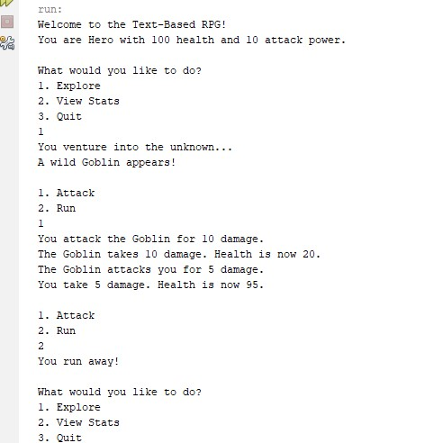

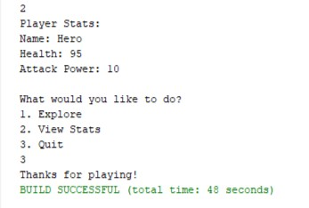

1. **Flowchart:**

**Return to Main Menu**

**View Stats**

**Quit**

**Is Enemy Alive?**

**Is Player Alive?**

**Player Attacks Enemy.**

**Enemy Attacks Player.**

**(if still alive)**

**Check Health**

**Player and Enemy**

**Run**

**Attack**

**Display Enemy Encounter Massage**

**Combat Loop**

**Explore**

**Main Menu**

1. **Explore**
2. **View Stats**
3. **Quit**

**User Makes Combat Choice**

**Display Combat Options**

1. **Attack**
2. **Run**

**End Game**

**Display Player Stats**

**Create Enemy**

**User Makes Choice**

**Initialize Game and Display Welcome Massage**